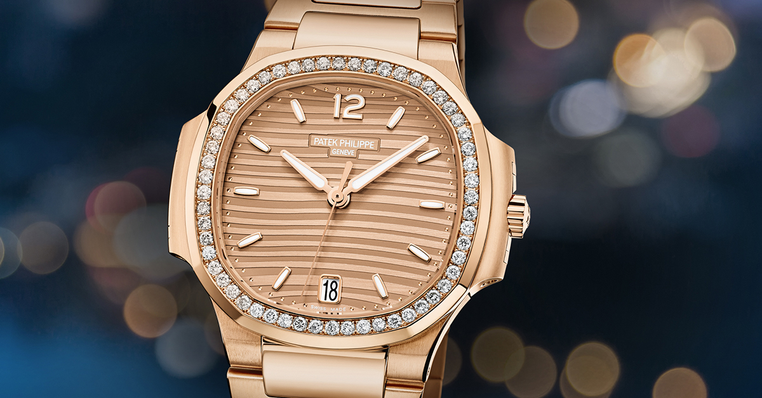Patek Philippe

Description: Patek Philippe is renowned for creating some of the world’s most prestigious women’s watches, combining exceptional craftsmanship, timeless elegance, and horological innovation. Designed for women who appreciate both artistry and technical excellence, Patek Philippe’s ladies' collections offer a variety of styles, from classic dress watches to sophisticated complications.

One of the most iconic models is the **Nautilus Ladies' Collection**, a refined take on the brand’s famous sports watch, featuring a sleek, rounded octagonal case, available in stainless steel, rose gold, or diamond-set variations. It offers both quartz and automatic movements, with luxurious dial options such as mother-of-pearl and sunburst designs. The **Aquanaut Luke** is another sporty yet elegant choice, featuring a modern, rounded case, available in steel or gold, often adorned with diamonds, and fitted with a comfortable rubber strap in various colors.